|  |  |
| --- | --- |
| **Air Quality Consultation:**  **Revocation of Air Quality Management Areas at Intack, Bastwell, and Four Lane Ends** |  |

**Background**

This consultation relates to the Air Quality Management Areas (AQMAs) in Blackburn. The Intack and Bastwell AQMAs were declared in 2005, and the Four Lane Ends AQMA was declared in 2012. They were all declared because levels of nitrogen dioxide (NO2), mainly from road vehicle exhaust emissions, were exceeding the annual mean national objective. NO2 is associated with adverse effects on human health and the environment.

However, air quality has improved at these locations. The NO2 quality standards and objectives in Table 2 of the [National Air Quality Strategy](https://assets.publishing.service.gov.uk/government/uploads/system/uploads/attachment_data/file/69336/pb12654-air-quality-strategy-vol1-070712.pdf) are being achieved and levels are likely to remain below the relevant concentrations for the foreseeable future.

As a consequence, Blackburn with Darwen Council are considering revoking the AQMAs and are inviting consultees to comment before deciding on the most appropriate way forward.

**Where are these AQMAs?**

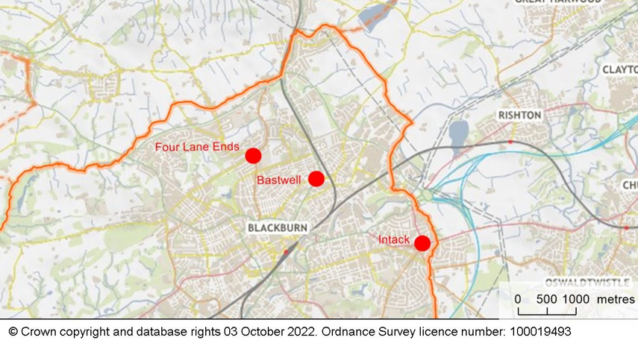

These AQMAs are at urban junctions in the north east of the Borough. They can be found at:

* Intack - what3words ///term.refuse.best or grid ref 370844 42833
* Bastwell - what3words ///trio.drop.comic or grid ref 369011 429165
* Four Lane Ends - what3words ///pull.tight.form or grid ref 367925 429579

**What is the evidence?**

NO2 levels have been monitored at these AQMAs since 2007. The measurement data has been compared against the relevant national objective for annual mean NO2, which is 40 µg/m3.

|  |  |
| --- | --- |
| **Annual Mean Nitrogen Dioxide at Intack AQMA** | |
|  |  |

|  |
| --- |
| **Annual Mean Nitrogen Dioxide at Bastwell AQMA** |
|  |

|  |  |
| --- | --- |
| **Annual Mean Nitrogen Dioxide at Four Lane Ends AQMA** | |
|  |  |

There hasn’t been an exceedance of the 40µg/m3 annual mean NO2 objective within any of the AQMAs since 2016. Exposure has been well below the objective for five years at Intack and Bastwell, and for four years at Four Lane Ends. Annual mean exposures have been well below 60µg/m3, so an exceedance of the 1-hour mean air quality objective is unlikely[1]. Nationally, roadside NO2 pollution has reduced in the long-term and in recent years, after being stable for most of the 2000s[2].

There was a sharp decline in NO2 exposure during 2020, due to a reduction in road traffic and the resulting exhaust emissions during the COVID pandemic. Traffic increased in 2021, but remained lower than in pre-pandemic levels[3]. Although traffic flows are expected to return to pre-covid levels, the long term improvement in air quality is likely to be sustained as newer road vehicles subject to stricter emission standards replace older more polluting vehicles.

There is a significant margin between current exposure and the national objective: 2021 exposure at Intack, Bastwell and Four Lane Ends was 78%, 74% and 73% of the objective respectively. There are no developments in local plans that are likely to substantially erode this margin.

In conclusion, there is strong evidence to support a conclusion that air quality has improved at these locations. The NO2 quality standards and objectives are being achieved and are likely to remain compliant for the foreseeable future. Year on year fluctuations in pollution levels are expected, caused by a range of factors including the weather, but an exceedance of the objective during the foreseeable future is considered unlikely.

**If a decision is taken to revoke these AQMAs, will air quality still be monitored at these locations?**

Yes. Monitoring at worse case locations would be undertaken at all former AQMAs, and all of our measurement information are published on an annual basis in the Council’s air quality Annual Status Review.

AQMAs have already been revoked elsewhere in our borough, at Earcroft, Darwen Town Centre, Witton, and at the junction of Burnley Road / Accrington. NO2 levels at these locations are still being monitored, and they remain below the quality standards and objectives.

**Have your say**

We would like to hear your views on the proposed revocation of these Air Quality Management Area and how it might affect you.

The consultation is open until <insert date> for your feedback.

To take part, you can:

* Telephone: 01254 267699;
* Email [publicprotection@blackburn.gov.uk](mailto:publicprotection@blackburn.gov.uk); or
* Write to Public Protection – Air Quality Consultation, Public Protection Service, Blackburn with Darwen Borough Council, Davyfield Road Depot, Roman Road Industrial Estate, Blackburn, BB1 2LX

If you would like more information please ask by phone or email.

End of document

1. https://laqm.defra.gov.uk/documents/NO2relationship_report.pdf
2. https://www.gov.uk/government/statistics/air-quality-statistics/ntrogen-dioxide
3. https://roadtraffic.dft.gov.uk/local-authorities/198